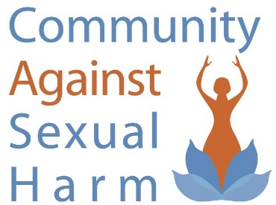

Dear Prospective Volunteer: Thank you for your interest in the volunteer program at Community Against Sexual Harm (CASH). Our volunteers work in a variety of roles and share their skills to help the organization fulfill its mission of assisting women who have been commercially sexually exploited through survivor-lead peer support and harm reduction services, while providing education about the harm inflicted on women and the community. Adult and college student volunteers must be at least 18 years of age.
Volunteers must also complete the following steps:
• Personal interview
• Orientation
• General training
• Additional training in the assigned job
We offer a variety of volunteer opportunities and make every effort to match your particular skills and interests with the organization’s needs. If you are interested in learning more about the volunteer program at CASH, please complete the attached application and return it to us via email to: lrust@cashsac.org.

CASH VOLUNTEER APPLICATION

Last Name: _______________________________ First Name: ____________________________
Address: ____________________________________________________________________________
Home/Work/Cell Phone: _______________________________________________________________
Email address: ________________________________________________________________________
Emergency Contact: ____________________________________________________________________
Education: ____________________________________________________________________________
I am currently: Employed Unemployed Retired In School
Work Experience:
____________________________________________________________________________________________________________________________________________________________________________________________________________________________________________________________________________________________________________________________________________________________________________
Volunteer Experience:
____________________________________________________________________________________________________________________________________________________________________________________________________________________________________________________________________________________________________________________________________________________________________________
Special Skills/Hobbies:
____________________________________________________________________________________________________________________________________________________________________________________________________________________________________________________________________________________________________________________________________________________________________________
What do you hope to gain from your volunteer experience/What type of volunteer experience are you seeking:
____________________________________________________________________________________________________________________________________________________________________________________________________________________________________________________________________________________________________________________________________________________________________________
I understand that I am seeking to volunteer my services to CASH without promise or expectation of compensation or future employment.
Signature: __________________________________________________ Date: _____________________

